[School Name]
[School Address Line 1]
[School Address Line 2]
[School Address Line 3]
[Tel:]
[Email:]

Dear Parents/Guardians,
Frog Parent Portal

I am pleased to able to inform you that you have access to our Frog Learning Platform. Unlike our school’s website, the information on Frog is personalised to you and your children. Frog will run on your computer, tablet or smartphone and comes with a free app called ‘My Frog’ - available from the Google Play Store and Apple App Store.
To access your account for the first time:
- Go to [ school’s Frog URL]
- On the login page select the Forgot Password link
- You will be prompted to enter your email address (this should be the email address you have previously supplied the school as contact email) and click Submit.
- Check your email inbox for an email from Frog (you may need to check the spam folder, if the email does not appear).
- Follow the email instructions to login, you will now see on the login screen your username and password reset form.
As all homework is now set on Frog, you will be able to see a summary of your children’s tasks in the My Frog app and the My Child’s Work section of the Parent Portal.

The parent portal also contains:
- All school letters
- A noticeboard informing you of the latest news
- Term dates
- A school calendar with parents evening, performances and other important dates.
- Email addresses of teaching staff
- School meals

Personalised information is also available:
- Attendance summaries, both by day and lesson
- Behaviour reports
- Academic achievements

We have included a parental advice section created by Alistair Smith - a nationally renowned educator. The ‘Parents As Learners’ site within Frog offers advice and guidance on how you can help your child learn and succeed.
Remember to install the My Frog app for easy access:
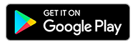 | More information:  frogeducation.com/myfrog | 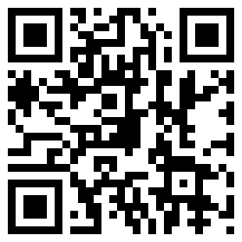
Yours sincerely,

A Smith
Headteacher

