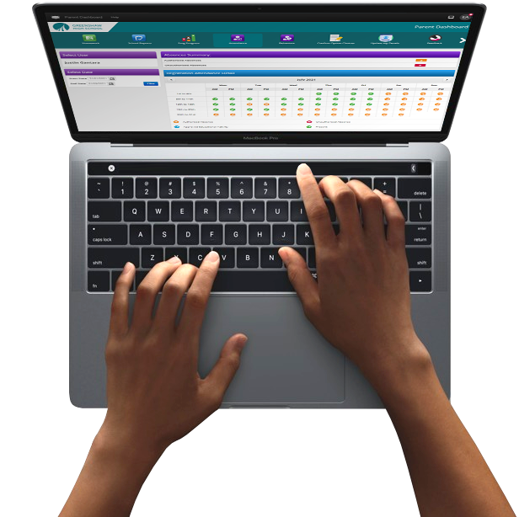
A guide to FrogParent

FrogParent
For FrogLearn Schools with SIMS

Education Software Solutions SIMS can provide your school with attendance, behaviour, reports and attainment (grades) data information about each child for an addition to your current FrogLearn licence.

Attendance and Behaviour data can be extracted from SIMS and imported into FrogLearn each evening as part of the scheduled import. You can also update this data manually.
Reports (or Linked Documents) can be prepared in SIMS and published in Frog when you’re ready.
Results Sets are also able to be synced with Frog and either published automatically or you can choose when to publish and which aspects to share.

Please note:
Frog already provides parent logins and a parent portal as part of your existing licence. Through these accounts, parents can see their children’s homework and ePortfolios. FrogParent provides additional data.
.

FrogParent Manager
Our FrogParent Manager application gives admins control over the data which is then accessed via the Parent Widgets or made available in the My Child/My Learning/My Class applications.
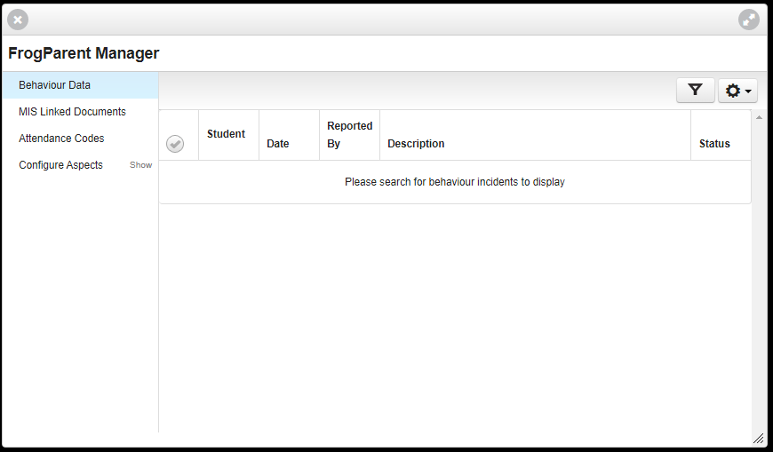

Parent Widgets
When enabled, a new category will appear in your widget editing panel, called Parent. These widgets display data about a parent’s children. They also interact with the Select User, Select Date and Select Subject widgets found in the Advanced category. Staff and Admins will be able to look up children using the Select User widget, however Parents will only see their children’s names as an option.

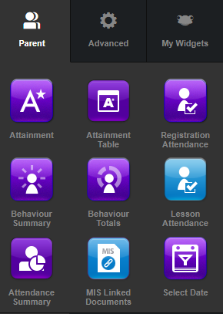
- Registration Attendance - An overview of a child’s attendance in school for the selected date range
- Behaviour Summary - A summary of positive and negative behaviours for the selected date range
- Behaviour Totals - The behaviour point totals for a selected date range
- Select Date - Allows for a date range to be specified
- Select User - Displays the child’s name. Should a parent have more than one child attending the school the widget will allow the ability to select a child
- Attainment Table - Provides tables from a Results Set, which can be configured to show specified aspects.
- Lesson Attendance - Shows an overview of a child's attendance in school by period, subject or detailed view for the selected date range.

Please note:
The Attainment widget is an older widget which the Attainment Table is designed to replace.

Behaviour Summary & Behaviour Totals Widgets
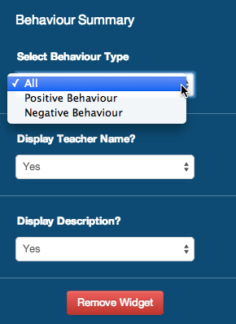
When placed on a site, the Behaviour Summary widget will allow the administrator to configure the following options:
- Select Behaviour Type
- Display Teacher Name
- Display Description
The Behaviour Totals widget requires no configuration; both positive and negative behaviour totals are displayed even if the school chooses not to display negative behaviour, i.e. this means that the Negative Behaviour Total will display as 0 if the school choose not to display negative behaviour.

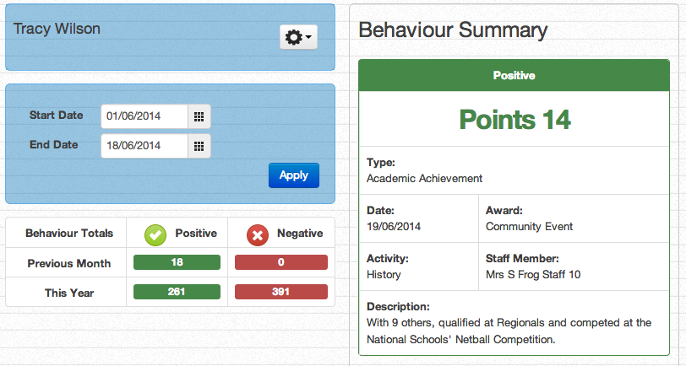
An example of the MIS data that will be seen when using the Behaviour Summary and Behaviour Totals widget:

Registration Attendance Widget
The Registration Attendance widget when placed on a site will allow the administrator to configure the following options:
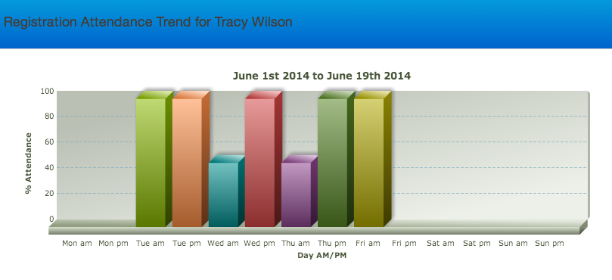
Registration Trend - Presents a summary of the child’s attendance in a bar graph

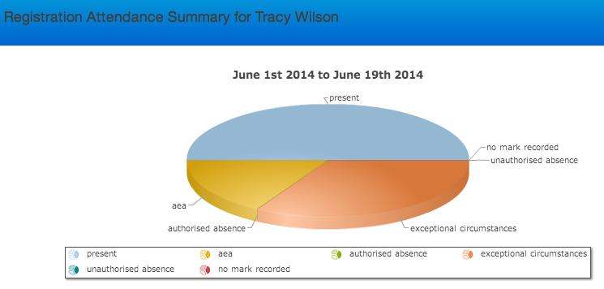
Registration Summary - Presents a summary of the child’s attendance in a pie chart

Registration Detail - Presents a detailed summary of the child’s attendance
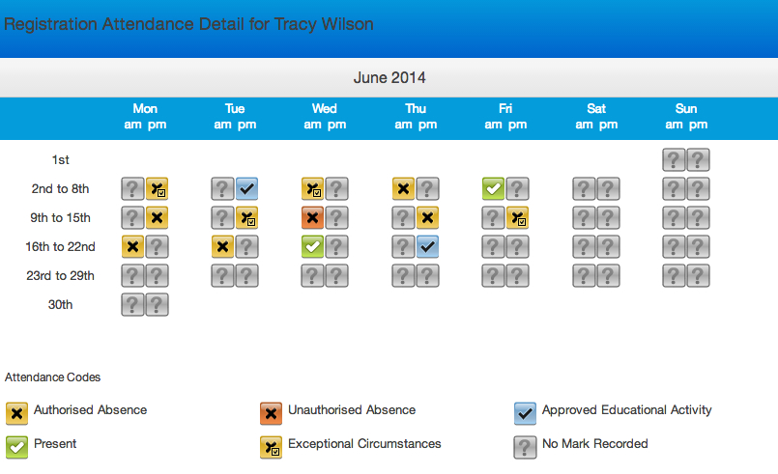

Attainment Widget
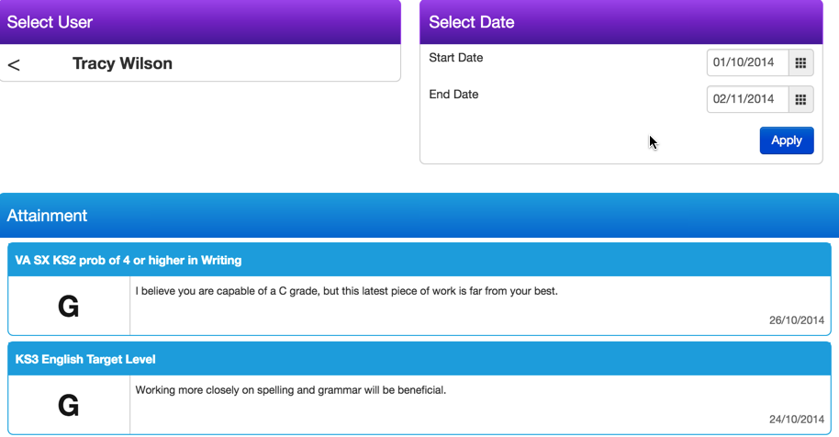
There is no configuration required for this widget. Below is an example of the MIS data that will be available through the Attainment widget:

Lesson Attendance Widget
The Lesson Attendance widget, when placed on a site, will allow an administrator to configure the following options:
- Period - Presents a summary of a child's attendance data for each period from the schools timetable in SIMS. The attendance for each period is expressed as a percentage in a bar graph for the selected date range.
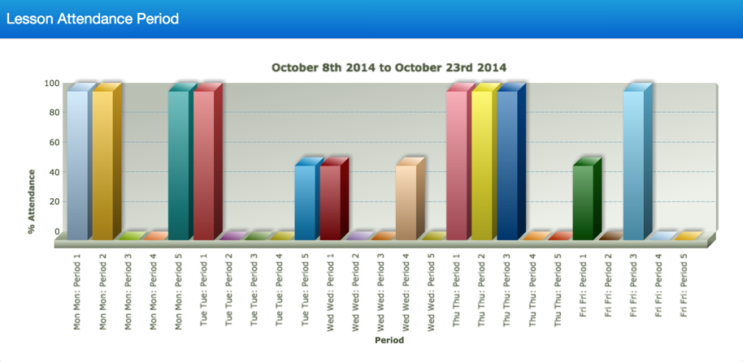

- Subject - Presents a summary of the child's attendance data for each subject from the schools timetable in SIMS. The attendance for each subject is expressed as a percentage in a bar graph for the selected date range.
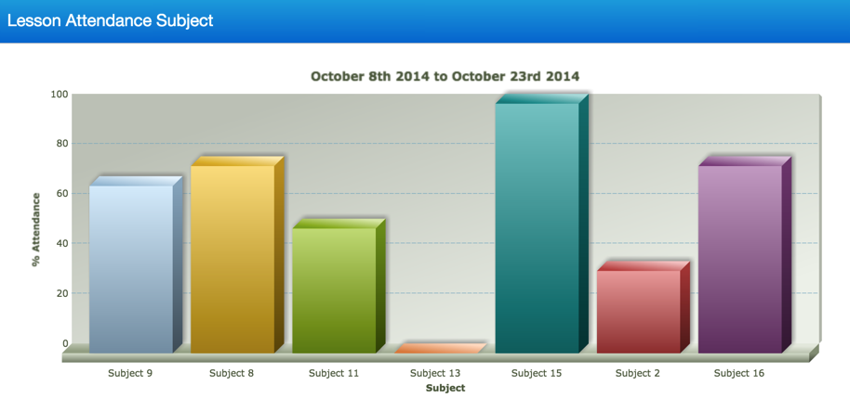

- Detail - Presents a detailed summary of the child's attendance for each subject for each day within the selected date range. Data will be displayed on a per week basis with arrows allowing the parent to scroll between weeks.
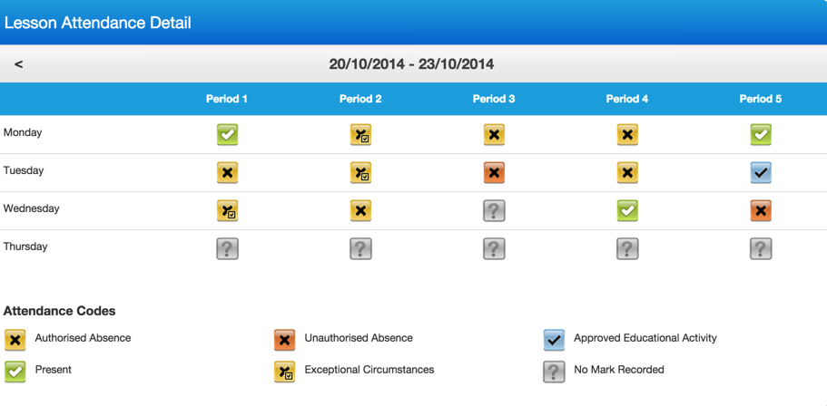

Please see below the symbols used in Detail view for the Lesson Attendance widget:
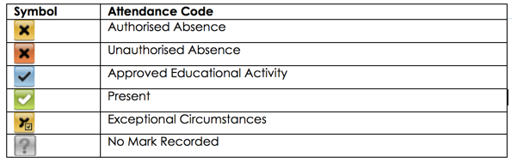

Attainment Table Widget
The Attainment Table widget can be configured in multiple ways to display specified aspects from a Results set.
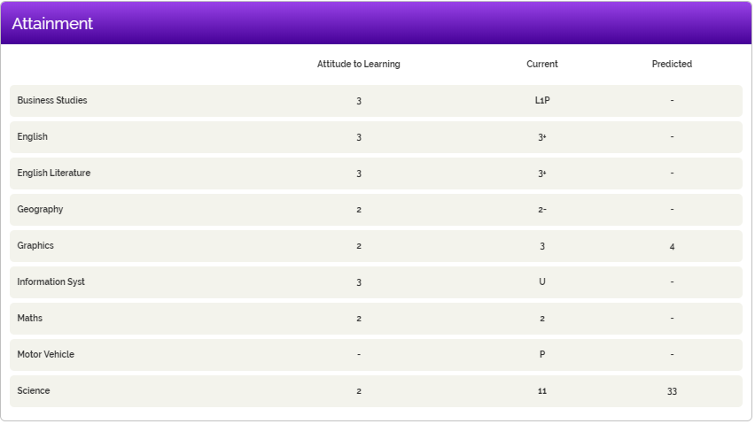
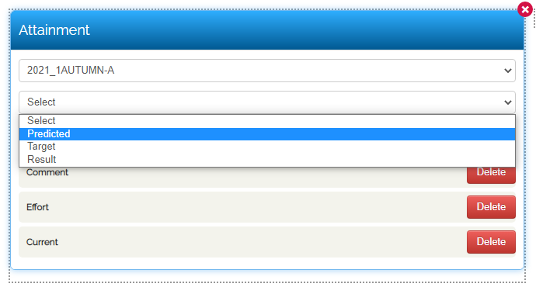

My Child
Within the My Child application, which also appears in MyFrog, all of the data above can also be displayed:
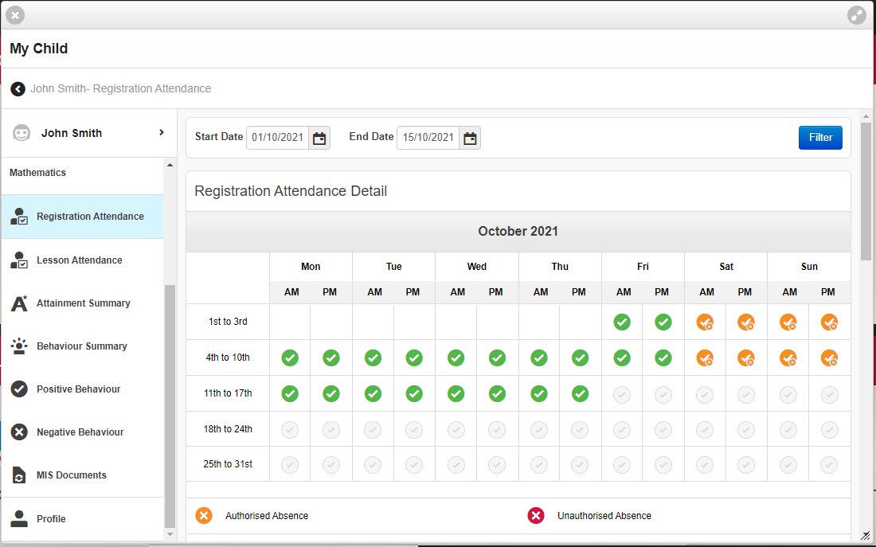
You can configure what is made visible in My Child via Groups & Policies:
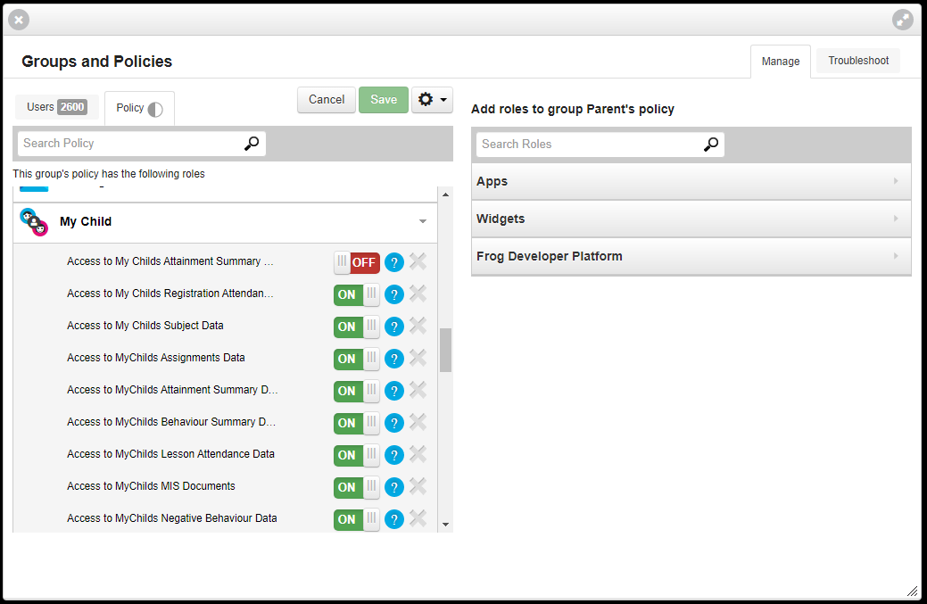

Next steps…
If you are interested in activating FrogParent for your school, please contact hello@frogeducation.com.
When activated, our Service Desk will walk your Admin team through the new tools and help you set them up. You can also use our video guides below:
https://schools.frogeducation.com/community/training/administratortraining/frogparent

